Ali Johar FA17-BECE-0013
LAB 12
TASK01
CODE
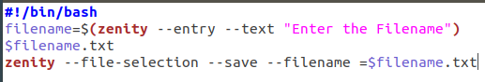

TASK02
CODE
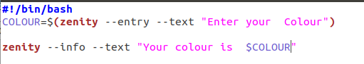

Execution
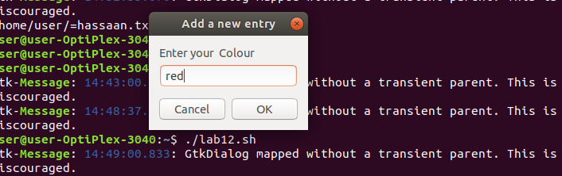

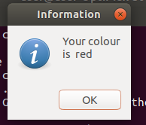
OUTPUT

TASK03

CODE

